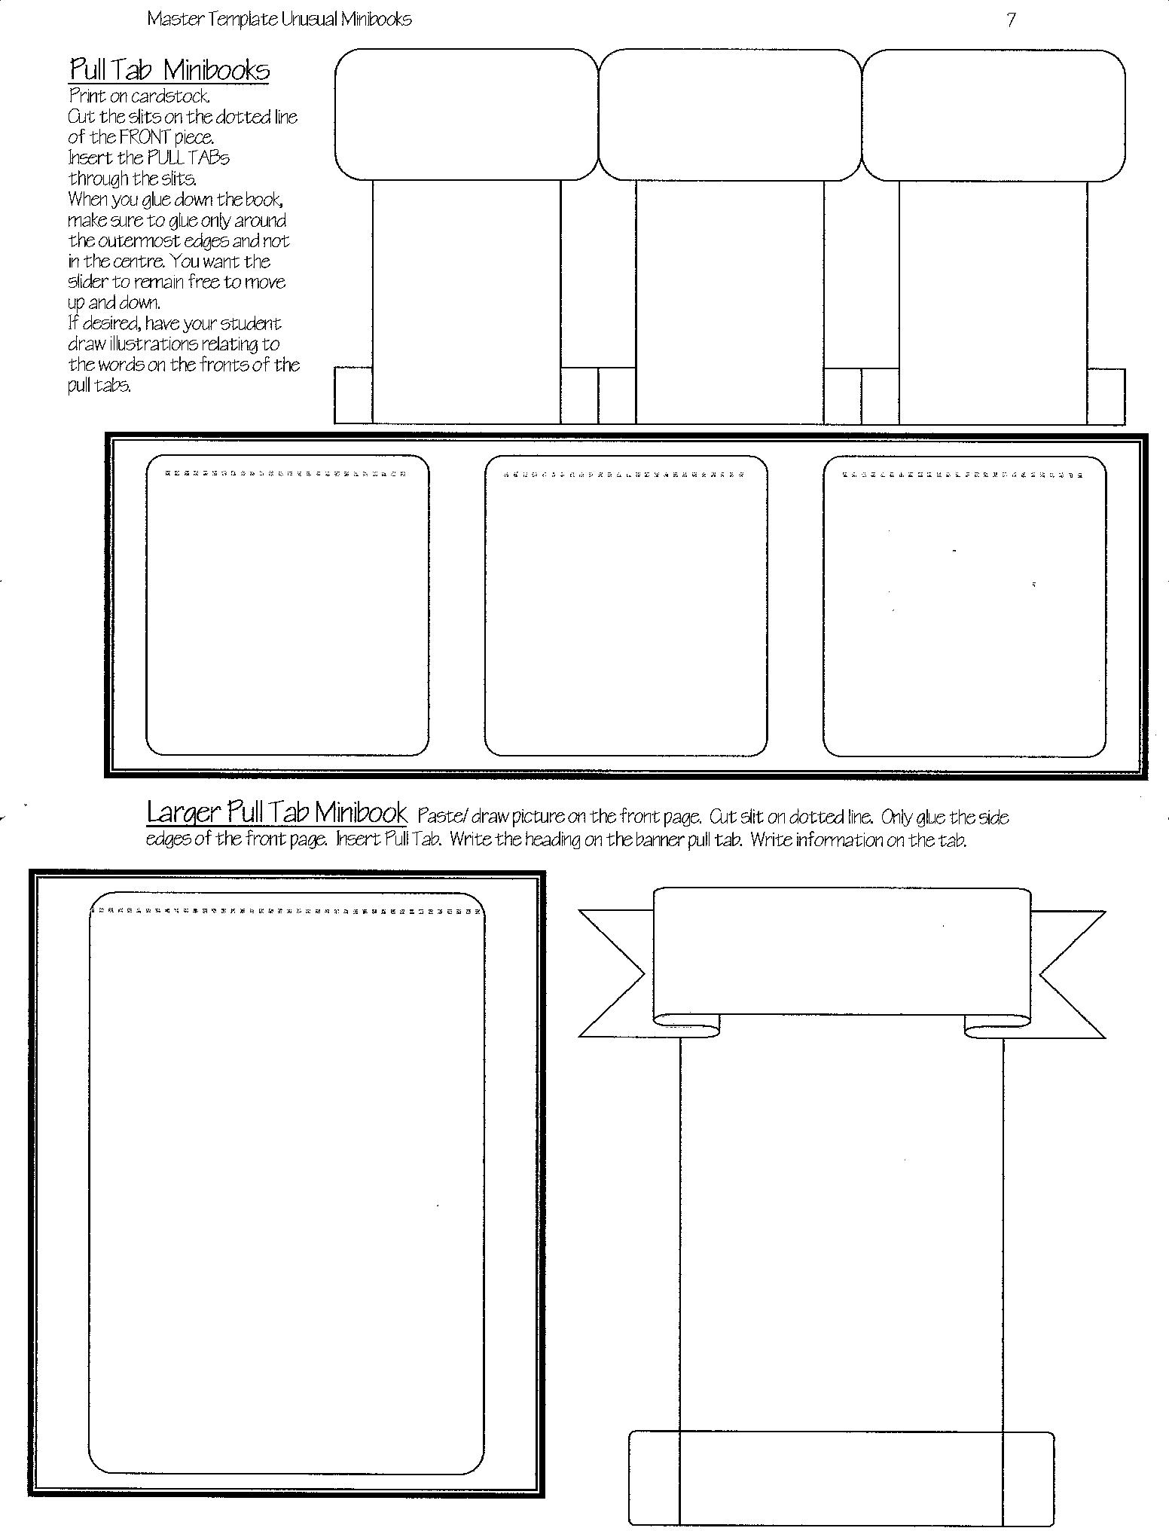 Pull Up

